Chip back potential is the level which bulk silicon is maintained by on-chip connection, or it is the level to which the chip back must be connected when specifically stated below. If no potential is given the chip back should be isolated.

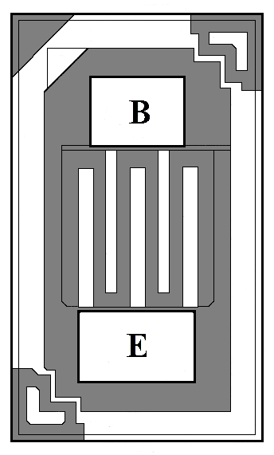
.012”
.019”
.0032 x .0048
.0032 x .0038

Top Material: Al
Backside Material: Au
Bond Pad Size: E = .0032” X .0048” B = .0032” X .0038”
Backside Potential:
Mask Ref: SMN

APPROVED BY: DK DIE SIZE .012” X .019” DATE: 7/19/23
MFG: ALLEGRO / SPRAGUE THICKNESS .006” P/N: 2N3250
DG 10.1.2

Rev B, 7/19/02

